A000-Mali-Sorko Culture-Nyerum Nommo Mermaid-Bronze-Gao Town-Bozo People-14th c

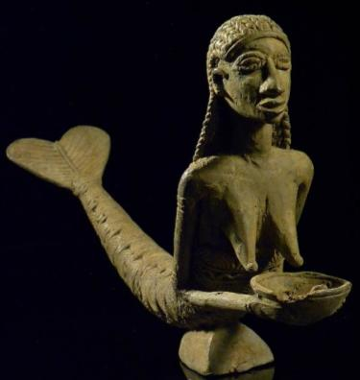

Fig. 1. Mali-Sorko Culture-Nyerum Nommo Mermaid-Bronze-Gao Town-Bozo People-14th c

**Case no.: 6**

**Accession Number:**

**Formal Label:** Mali-Sorko Culture-Nyerum Nommo Mermaid-Bronze-Gao Town-Bozo People-14th c **Display Description:** The Sorko people were semi-nomadic and most were Mande speakers of the northern group of the Bozo People who depended on fishing on the middle Niger and Bani Rivers in the Republic of Mali. In the 14th c CE, the Bozo people numbered ca 5,000 and were in close contact with the Dogon people, and they inherited some Dogon cosmology that had its roots with the Tellem, especially the figures of Nyerem and Nommo. This bronze lost wax casting of the Sorko version of Nyerum-Nommo combines the aspect of Nommo who provides the water for the people with the female aspect of Nyerum who supervises the proper use of water.

**LC Classification:** DT551.42

**Date or Time Horizon:** 14th c

**Geographical Area:** site of Gao, Mali.

**Map:**

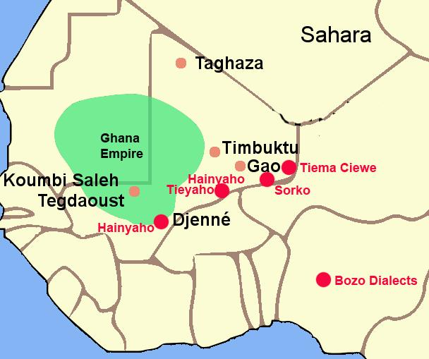

Fig. 2. The Ghana Empire 1000-1400 CE showing Sorko and other ethnolinguistic groups along the Niger River. After <https://i.pinimg.com/564x/c6/a7/9b/c6a79b7443105f363ff965ebf420b7fd.jpg>

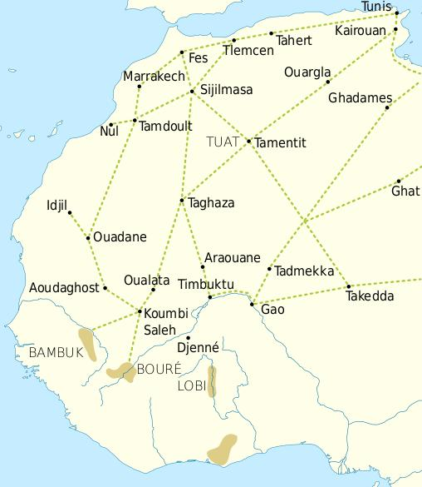

Fig. 3. Trade routes of the Western Sahara c. 1000-1500. Goldfields are indicated by light brown shading. After https://i.pinimg.com/564x/69/15/ce/6915ce6f4fd34025787fe59bd44f9eae.jpg

This trade resulted in an increasing surplus that helped expand urban centers such as Gao, Timbuktu and Djenné. In this context the Bozo founded the cities of Djenné and Mopti, where they built magnificent mosques of mud brick.

**GPS coordinates:** Gao, Mali : [16°16′N 0°03′W](https://tools.wmflabs.org/geohack/geohack.php?pagename=Gao&params=16_16_N_0_03_W_region:ML_type:city)

**Cultural Affiliation:**

**Medium:** bronze

**Dimensions:**

**Weight:**

**Condition: original**

**Provenance:** Old French collection.

**Discussion:**

The Sorko (or Bozo), a West African ethnic group, are considered "the masters of the river" and **are** the principal fishing people of the Inner Niger Delta in Mali. The name *Bozo* is thought to derive from the neighboring Bambara people's word "*bo-so*," meaning "bamboo" or "grass house" which has been accepted as referring to the whole of the ethnic group. However, local people refer to themselves by one of four dialects: Hainyaho (a few thousand speakers), Tièma cièwe (2,500 speakers in 1991), Tiéyaho (a few thousand speakers) and Sorko or Sorogama (200,000 speakers in 2005) all of which form a branch of northwestern Mande languages.

The Sorko culture took shape under the Ghana Empire in what is now southeastern Mauritania and western Mali that was founded before 830 CE, when the Bozo took possession of the banks of the Niger. This event was of great importance since the domesticated camel provided transport for trans-Saharan trade in gold, ivory, salt and natron which could then be exchanged for manufactured goods to Mediterranean ports connecting to Europe, to Egypt and to the Middle East.

Gao was important in the trans-Saharan trade and was ruled by a Muslim in the 10th century. In the 13th century Gao became part of the Mali Empire. When it was liberatedin the 15th century under Sonni Ali (ruled 1464–1492) it became the capital of the Songhai Empire (seeWiki).

**References:**

Gaillais, Jean. 1978-80. *La delta intérieur du Niger*. Mémoires de l'Institut Fondamental de l'Afrique Noire 79. Amsterdam: Swets & Zeitlinger, 1978-80.

Grunne, Bernard de. 1982. *La statuaire en terre cuite du delta intérieur du Niger au Mali = Figürliche Terrakotten aus dem Gebiet des Niger-Binnendeltas in Mali = The terracotta statuary of the inland delta of the Niger in Mali.* München: Galerie Biedermann

Ligers, Z. 1964-1969. *Les Sorko (Bozo): Maîtres du Niger: Étude ethnographique*. Volumes 1-4. Paris: Librairie des Cinq Continents.